Step 2: Download & Install Virtualbox on your laptop/PC: https://virtualbox.org/wiki/Downloads
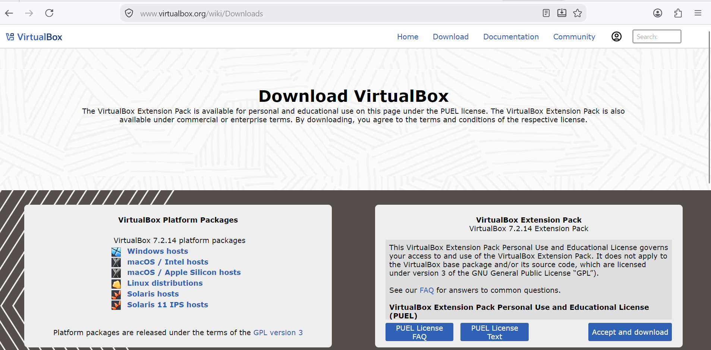
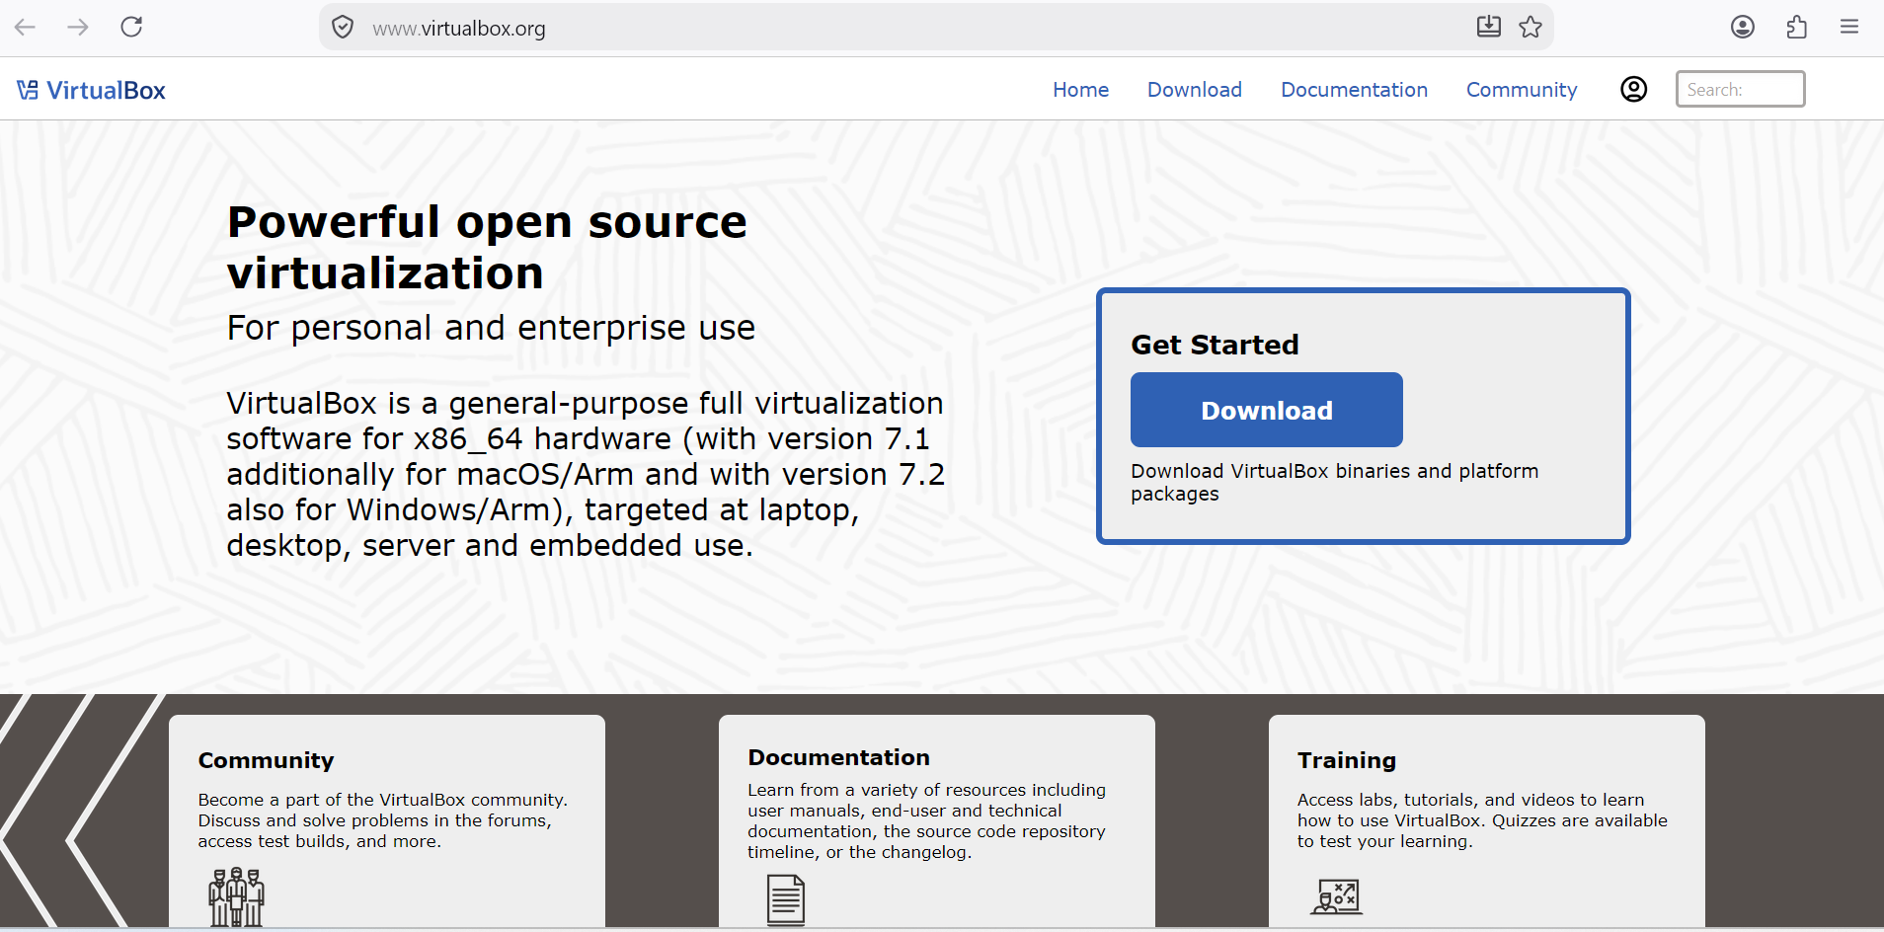
Click the following button:
Windows hosts – For windows
MacOS/Intel hosts – For mac

